Epoch Spring Camp 2026
Take Home Assignment-3
Name: Nikhil S Ramcharan
GitHub username: ErrorNik14 (sleepynik07

Matrix Factorisation model
Simply performed dot products of the embedded vectors of users and items, then performed back-propagation using ADAM optimiser, until satisfactory Hit@K was achieved,
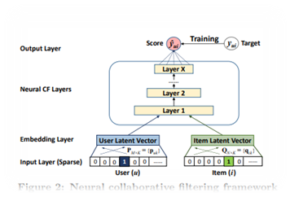
Neural Collaborative Filtering model
I used the given below schematic for the MLP architecture used in the model.
- Input Layer – In: 2 * embed_dimension, Out: 128
- ReLU
- Dropout(0.2)
- Hidden Layer 1 – In: 128, Out: 32
- ReLU
- Dropout(0.2)
- Hidden Layer 2 – In: 32, Out: 8
- ReLU
- Dropout(0.2)
- Output Layer – In: 8, Out: 1
- Sigmoid
Additionally, I first tried using the Stochastic Gradient Descent (SGD) optimizer, however I opted to go with the
Adaptive Moment Estimation (ADAM) optimiser, for faster gradient descent.
Neural Matrix Factorization model
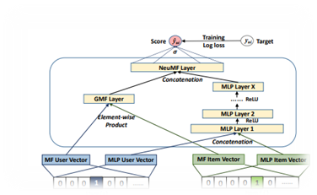
I used the given below schematic for the MLP architecture used in the model.
- Input Layer – In: 2 * embed_dimension, Out: 128
- ReLU
- Dropout(0.2)
- Hidden Layer 1 – In: 128, Out: 32
- ReLU
- Dropout(0.2)
- Hidden Layer 2 – In: 32, Out: 8
- ReLU
- Dropout(0.2)
Then I concatenated the output of MF and MLP and fed it into the NeuMF layer, represented below…
- Output Layer – In: 9, Out: 1
- Sigmoid
I have added two mechanisms to ensure equal weightage of MLP and MF portions of this model
- Additional parameter “alpha” that acts as a weight for each model during concatenation.
- Different embedding dimensions for the MF and MLP models, to again make them more equal.

Initially, I wanted to add PNS (popular negative sampling) instead of the current RNS being used, but could not as the data did not have many repetitions, which is something PNS leverages…
In addition to this, I added a decay_weight in the optimiser, which should act as a regularizer and prevent most of the over-fitting.

Additionally,
I obtained the following results. (for epochs=20, lr=5e-4, and embed_dimension=100)
( for the NMF model, MF_embed_dimension = 100, MLP_embed_dimension=50, owing to how dominant MLP results are)
No. of neg samples | Hit@10 (MF) | Hit@10 (NCF/MLP) | Hit@19 (NMF) | Accuracy  (MF) | Accuracy  (NCF/MLP | Accuracy  (NMF)
1 | 0.1326 | 0.5099 | 0.5203 | 1.95 % | 10.962 % | 12.163 %
2 | 0.1555 | 0.5469 | 0.5281 | 2.591 % | 14.826 % | 14.384 %
5 | 0.4595 | 0.5739 | 0.6070 | 12.858 % | 13.228 % | 17.824 %
10 | 0.4486 | 0.6465 | 0.6625 | 8.072 % | 20.795 % | 21.409 %
25 | 0.4428 | 0.6596 | 0.6709 | 2.501 % | 22.005 % | 21.968 %
50 | 0.4384 | 0.6438 | 0.6472 | 1.4 % | 20.659 % | 21.056 %

We can observe how the NMF and MLP model consistently outperform the MF model, while higher negative samples can result in that performance gap becoming smaller. We can conclude that the MF model relies much more strongly on the existence of negative samples for classification, than the MLP and NMF models. Infact, if we consider a case where we increase the number of negative samples a lot, the MF Model will likely perform than the MLP model. The same isn’t very apparent for the accuracy metrics of the MF model…
We can see a drop in the performance of the MLP and NeuMF models in the last 2 rows. This is an indication of overfitting – the models have turned to memorising the training data, and thus have performed more poorly in the testing data.
The NeuMF model performs better than the first two in almost all cases, because it is able to keep track of linear trends using the MF model, and account for non-linearities at low no. of negative samples using the NCF/MLP model.
Increasing the embed dimension will result in higher scores for all the models, as it results in more “accurate” embedding vectors with respect to the original dataset.

I would like to end of my report with an apology for submitting all of this 2-days past the deadline…

